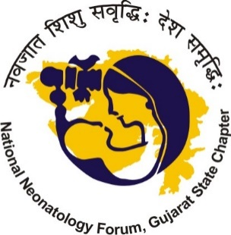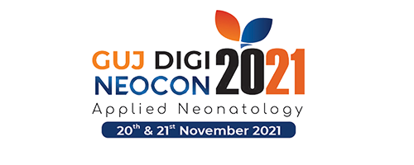

**Call for Free & Award papers for presentation at GUJdigiNeocon -2021**

**Submit:**

* Online

OR

* Email: [nnfgujaratcore2020@gmail.com](mailto:nnfgujaratcore2020@gmail.com)

The Scientific Committee invites delegates who wish to give a presentation during the GUJdigiNeocon -2021, Conference of National Neonatology Forum Gujarat state Chapter to be held from November 20th- 21st, 2021 **ONLINE**, to submit the 'Abstracts' of their scientific studies.

**Cash rewards for the papers securing top spot in each category and respective session.**

**Conference registration Compulsory**

1. **Paper Category: Free Papers:**

The selection of free papers will be decided by the scrutinizing committee from amongst the abstracts received and authors will be informed accordingly.

You may submit the same abstract as e-Poster separately (see instructions for e-poster submission).

The text of the `Abstract’ should not contain more than 250 words. It should be structured as far as possible in the following manner (Except Case Reports):

Name of the authors after the Title and the presenting Author’s name should be the **FIRST** name. No more than 4 authors.

Then:

1. Introduction (b) Aims & Objectives (c) Material & Methods (including statistical methods where relevant) (d) Results (e) Conclusions.

Instructions:

1. Abstracts can be submitted ONLINE or via email ID: [nnfgujaratcore2020@gmail.com](mailto:nnfgujaratcore2020@gmail.com) as an attached word document.
2. ONLY online submission is accepted
3. The deadline for sending in abstracts is 10th November,2021. This deadline will be strictly observed.
4. ONLY Abstracts NO full manuscript in this category.
5. Authors will be informed of the acceptance by 15th November 2021.
6. **Paper Category: Award Papers:**

The selection of free papers will be decided by the scrutinizing committee from amongst the abstracts and full paper received and authors will be informed accordingly.

The text of the `Abstract’ should not contain more than 250 words and full text should not be more than 2000 words. It should be structured as far as possible in the following manner.

Name of the authors after the Title and the presenting Author’s name should be the FIRST name. No more than 4 authors.

Then:

1. Introduction (b) Aims & Objectives (c) Material & Methods (including statistical methods where relevant) (d) Results (e) Conclusions.

Instructions:

1. Abstracts and full text can be submitted ONLINE or via email ID: [nnfgujaratcore2020@gmail.com](mailto:nnfgujaratcore2020@gmail.com) as an attached word document.
2. ONLY online submission is accepted
3. The deadline for sending in abstracts is 10th November,2021. This deadline will be strictly observed.
4. The FULL award paper should be in the style of “Journal of Neonatology”. Click the link for instructions: <https://journals.sagepub.com/author-instructions/NNT>
5. No Case reports accepted for this category.
6. Authors will be informed of the acceptance by 15th November 2021.
7. The papers not accepted for award competition will not be presented in any other category.

For any clarifications, please write to [nnfgujaratcore2020@gmail.com](mailto:nnfgujaratcore2020@gmail.com)

NNF Gujarat State chapter & Organizing Committee of GUJdigiNeocon -2021 wishes you all the best.

Dr. Mohit Sahni Dr. Snehal Desai

President, NNF GSC Secretary, NNF GSC